Let's get Hooked!
- What is the difference between Named Export, Default export and * as export?
- Named Export: explicitly export variables, functions, or classes by name.
- We must use the same name
- Multiple allowed • Imported with { } • Exact names
export const a = 10;
export function sum() {}
export class User {}
When to use
✔ When a file/module exposes multiple functions/values.
✔ When you want flexibility—import only what you need.
- Default Export: Each module can have only one default export.
• Only one per file • Imported without { }• Can be renamed freely
import anything from './module';
When to use
✔ When a module mainly exports one primary thing.
✔ Cleaner import without braces {}.
- * as Export / Import (Namespace Import): mostly an import pattern, not an export pattern
- mostly an import pattern, not an export pattern
- It imports all named exports.
- Does NOT import the default export (unless accessed specially in TS).
- Imports all named exports as one object • Useful for grouping utilities
import * as Utils from './utils';
Then use: Utils.sum();
Utils.a;
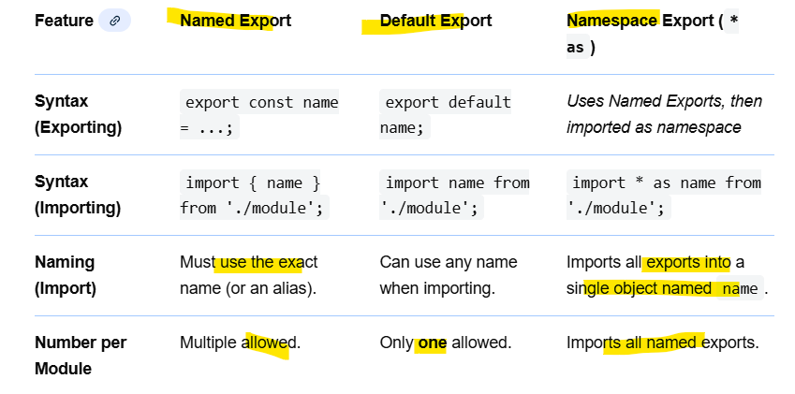

- What is the importance of config.js file?
It serves one core purpose: config.js is a centralized place to store configuration values.
This helps keep your code clean, maintainable, and environment-friendly.
- Centralized Configuration: Instead of scattering API URLs, constants, secrets, feature flags, etc., across many files, you keep them in one place.
- Makes Environment Management Easier can create different config files:
- Avoids Magic Numbers / Hardcoded Values
- Easier Maintenance:If you need to change API base URL or version, change it in one file, not everywhere in your codebase.
- Improves Reusability: Common config values used across different modules/components can be imported anywhere.
- Helps with Build-Time Optimization
- Useful for Feature Flags and Toggles

- What are React Hooks?
- React Hooks are functions that let functional components manage state, side effects, and other React features.
- introduced Hooks in React 16.8 to make components more powerful and simpler.
- After Hooks:
✔ Functional components can handle state
✔ Functional components can handle side effects
✔ Cleaner, reusable logic
✔ No need for classes
- Why do we need a useState Hook?
- it allows functional components to store and manage state.
- Before Hooks, only class components could have state.
Now, with useState, functional components can also be dynamic and interactive.
- Why do we need useState?
- To store data that changes over time: useState allows you to store mutable values, such as:
- form inputs
- counters
- toggles
- fetched data
- UI state (modal open/close)
const [count, setCount] = useState(0);

- To trigger re-renders: If a variable changes normally, React doesn’t know it should update the UI.
let x = 0;
x = x + 1; // UI will NOT update
With useState:
setCount(count + 1); // UI will update
- To remember values between component renders: Every time a component re-renders, all variables redeclare. But React remembers state values across renders.
- Makes functional components powerful: Without useState, functional components would be:
  - static,
  - unable to handle user interactions,
  - unable to update UI based on events

- Cleaner and simpler than class component state: Much easier. No this, no binding.
Traditionally in classes:
this.state = { count: 0 };
this.setState({ count: this.state.count + 1 });
With hooks:
const [count, setCount] = useState(0);

- Helps handle small and simple state updates

